IC設計實驗期中考練習1 2024

班級: 學號: 姓名: 成績:

- The input signal rising/falling time is 0.5ns. The output loading is 1pf. Please design the 3-input dynamic XOR with the same delay time as 1ns for various input patterns. (0.95ns < T₀₀₀, T₀₀₁, T₀₁₀, T₀₁₁, T₁₀₀, T₁₀₁, T₁₁₀, T₁₁₁ < 1.05ns) (Function Validation: 30%, 0.8ns < Delay < 1.2ns: 30%, 0.9ns < Delay < 1.1ns: 10%, 0.95ns < Delay < 1.05ns: 10%)

- Please write down your consideration during constructing function and sizing procedure. (20%)

IC設計實驗期中考練習2 2024

班級: 學號: 姓名: 成績:

- The input signal rising/falling time is 0.5ns. The output loading is 1pf. Please design the 3-input pseudo nMOS XOR with the same delay time as 1ns for various input patterns. (0.95ns < T₀₀₀, T₀₀₁, T₀₁₀, T₀₁₁, T₁₀₀, T₁₀₁, T₁₁₀, T₁₁₁ < 1.05ns) (Function Validation: 30%, 0.8ns < Delay < 1.2ns: 30%, 0.9ns < Delay < 1.1ns: 10%, 0.95ns < Delay < 1.05ns: 10%)

- Please write down your consideration during constructing function and sizing procedure. (20%)

IC設計實驗期中考練習3 2024

班級: 學號: 姓名: 成績:

- The input signal rising/falling time is 0.5ns. The output loading is 1pf. Please design the 3-input pass-transistor XOR with the same delay time as 1ns for various input patterns. (0.95ns < T₀₀₀, T₀₀₁, T₀₁₀, T₀₁₁, T₁₀₀, T₁₀₁, T₁₁₀, T₁₁₁ < 1.05ns) (Function Validation: 30%, 0.8ns < Delay < 1.2ns: 30%, 0.9ns < Delay < 1.1ns: 10%, 0.95ns < Delay < 1.05ns: 10%)

- Please write down your consideration during constructing function and sizing procedure. (20%)

IC設計實驗期中考練習4 2024

班級: 學號: 姓名: 成績:

- The input signal rising/falling time is 0.5ns. The output loading of Co and S is 1pf. Please design the single bit pseudo-nMOS Full-adder with the same rising time and falling time as 1ns in both S and Co. (0.95ns < T₀₀₀, T₀₀₁, T₀₁₀, T₀₁₁, T₁₀₀, T₁₀₁, T₁₁₀, T₁₁₁ < 1.05ns) (You can only tune the size of transistor. Altering the circuit architecture is not allowed.)
(Function Validation: 30%, 0.8ns < Delay < 1.2ns: 30%, 0.9ns < Delay < 1.1ns: 10%, 0.95ns < Delay < 1.05ns: 10%)
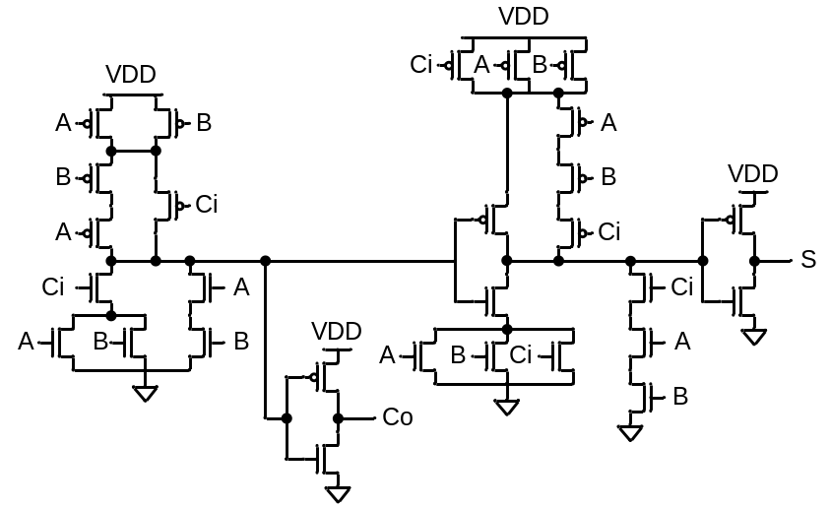
(Reference Full-Adder Circuit)

- Please write down your consideration during constructing function and sizing procedure. (20%)

IC設計實驗期中考練習5 2024

班級: 學號: 姓名: 成績:

- The input signal rising/falling time is 0.5ns. The output loading of Co and S is 1pf. Please design the single bit dynamic CMOS Full-adder with the same rising time and falling time as 1ns in both S and Co. (0.95ns < T₀₀₀, T₀₀₁, T₀₁₀, T₀₁₁, T₁₀₀, T₁₀₁, T₁₁₀, T₁₁₁ < 1.05ns) (You can only tune the size of transistor. Altering the circuit architecture is not allowed.)
(Function Validation: 30%, 0.8ns < Delay < 1.2ns: 30%, 0.9ns < Delay < 1.1ns: 10%, 0.95ns < Delay < 1.05ns: 10%)
(Reference Full-Adder Circuit)

- Please write down your consideration during constructing function and sizing procedure. (20%)

IC設計實驗期中考練習6 2024

班級: 學號: 姓名: 成績:

- The input signal rising/falling time is 0.5ns. The output loading is 0.5pf. Please design the 3-input pass-transistor A*B+C*(B*D+A*E) with the same delay time as 1ns for various input patterns. (0.95ns < T₀₀₀, T₀₀₁, T₀₁₀, T₀₁₁, T₁₀₀, T₁₀₁, T₁₁₀, T₁₁₁ < 1.05ns) (Function Validation: 30%, 0.8ns < Delay < 1.2ns: 30%, 0.9ns < Delay < 1.1ns: 10%, 0.95ns < Delay < 1.05ns: 10%)

- Please write down your consideration during constructing function and sizing procedure. (20%)

IC設計實驗期中考練習7 2024

班級: 學號: 姓名: 成績:

- The input signal rising/falling time is 0.5ns. The output loading of A=B, A>B, and A<B are all 0.5pf. Please design the comparator by using pseudo-nMOS with the same rising time and falling time as 1ns. (0.95ns < T₀₀, T₀₁, T₁₀, T₁₁ < 1.05ns) (You can only tune the size of transistor. Altering the circuit architecture is not allowed.)
(Function Validation: 30%, 0.8ns < Delay < 1.2ns: 30%, 0.9ns < Delay < 1.1ns: 10%, 0.95ns < Delay < 1.05ns: 10%)

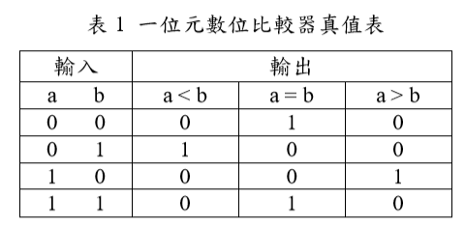
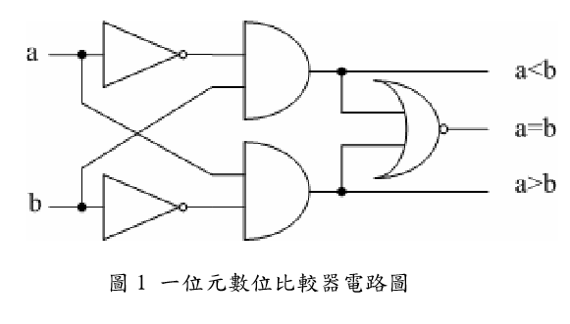
- Please write down your consideration during constructing function and sizing procedure. (20%)

IC設計實驗期中考練習8 2024

班級: 學號: 姓名: 成績:

- The input signal rising/falling time is 0.5ns. The output loading of A=B, A>B, and A<B are all 0.5pf. Please design the comparator by using dynamic CMOS logic with the same rising time and falling time as 1ns. (0.95ns < T₀₀, T₀₁, T₁₀, T₁₁ < 1.05ns) (You can only tune the size of transistor. Altering the circuit architecture is not allowed.)
(Function Validation: 30%, 0.8ns < Delay < 1.2ns: 30%, 0.9ns < Delay < 1.1ns: 10%, 0.95ns < Delay < 1.05ns: 10%)

- Please write down your consideration during constructing function and sizing procedure. (20%)

IC設計實驗期中考練習9 2024

班級: 學號: 姓名: 成績:

- The input signal rising/falling time is 0.5ns. The output loading of A=B, A>B, and A<B are all 2pf. Please design the comparator by using pass-transistor with the same rising time and falling time as 1ns. (0.95ns < T₀₀, T₀₁, T₁₀, T₁₁ < 1.05ns) (You can only tune the size of transistor. Altering the circuit architecture is not allowed.)
(Function Validation: 30%, 0.8ns < Delay < 1.2ns: 30%, 0.9ns < Delay < 1.1ns: 10%, 0.95ns < Delay < 1.05ns: 10%)

- Please write down your consideration during constructing function and sizing procedure. (20%)

IC設計實驗期中考練習10 2024

班級: 學號: 姓名: 成績:

- The input signal rising/falling time is 0.5ns. The output loading is 2pf. Please design the circuit by using pass-transistor with the same rising time and falling time as 1ns. (0.95ns < T₀₀, T₀₁, T₁₀, T₁₁ < 1.05ns)
(Function Validation: 30%, 0.8ns < Delay < 1.2ns: 30%, 0.9ns < Delay < 1.1ns: 10%, 0.95ns < Delay < 1.05ns: 10%)
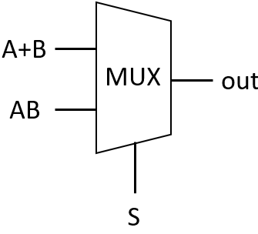
圖1 要求相關電路
- Please write down your consideration during constructing function and sizing procedure. (20%)

